# 1. INTRODUCTION

Agriculture is a backbone of the india economy.It is activity and is closely related to the natural environment.Agricultural is also called farming or husbandry.The team agriculture has been derived from the latin word “AGER” meaning field and “CULTURA” meaning cultivation.Food grains are most important agricultural products made in india.India exports agro products like tea,coffee,spices etc..Around 58% population of india depends on agriculture.

* 1. **OVERVIEW**

India is among the highest-ranking countries in production volume for various commodities like rice,cotton,dairy,fruits,vegetables,meat and seafood.Some claim Indian agriculture began by 9000BC as a result of early cultivation of plants and domestication of crops.Agriculture is a main source for livelihood,it provides a source for the people to earn.Most of the population in the rural area is dependent on agriculture as their main source of income.

Its gross irrigated crop area of 82.6 million hectares (215.6 million acres) is the largest in the world.India is one of the major players in the agriculture sector worldwide and it is the primary source of livelihood for ~55% of india’s population.consumer spending in india will return to growth in 2021post of the pandemic-led contraction,expanding by as much as 6.6%.Thus , farmers become an integral part of the sector to provide us with a means of sustenance.

**1.2 PURPOSE**

All humans depend on agriculature for food.Urban-industrial societies depend on the base of food surplus generated by farmers and herders.Without agriculture there could be no cities,universities,factories,or officers.Today agriculture remains the most important economic activity in world.Agriculture employs 45% of the working population (only two percent in US) .In some parts of asia and Africa,over 80% of the labor force is engaged in agriculture.

**2.PROBLEM DEFINITION AND DESIGN THINKING**

**2.1 EMPATHY MAP**

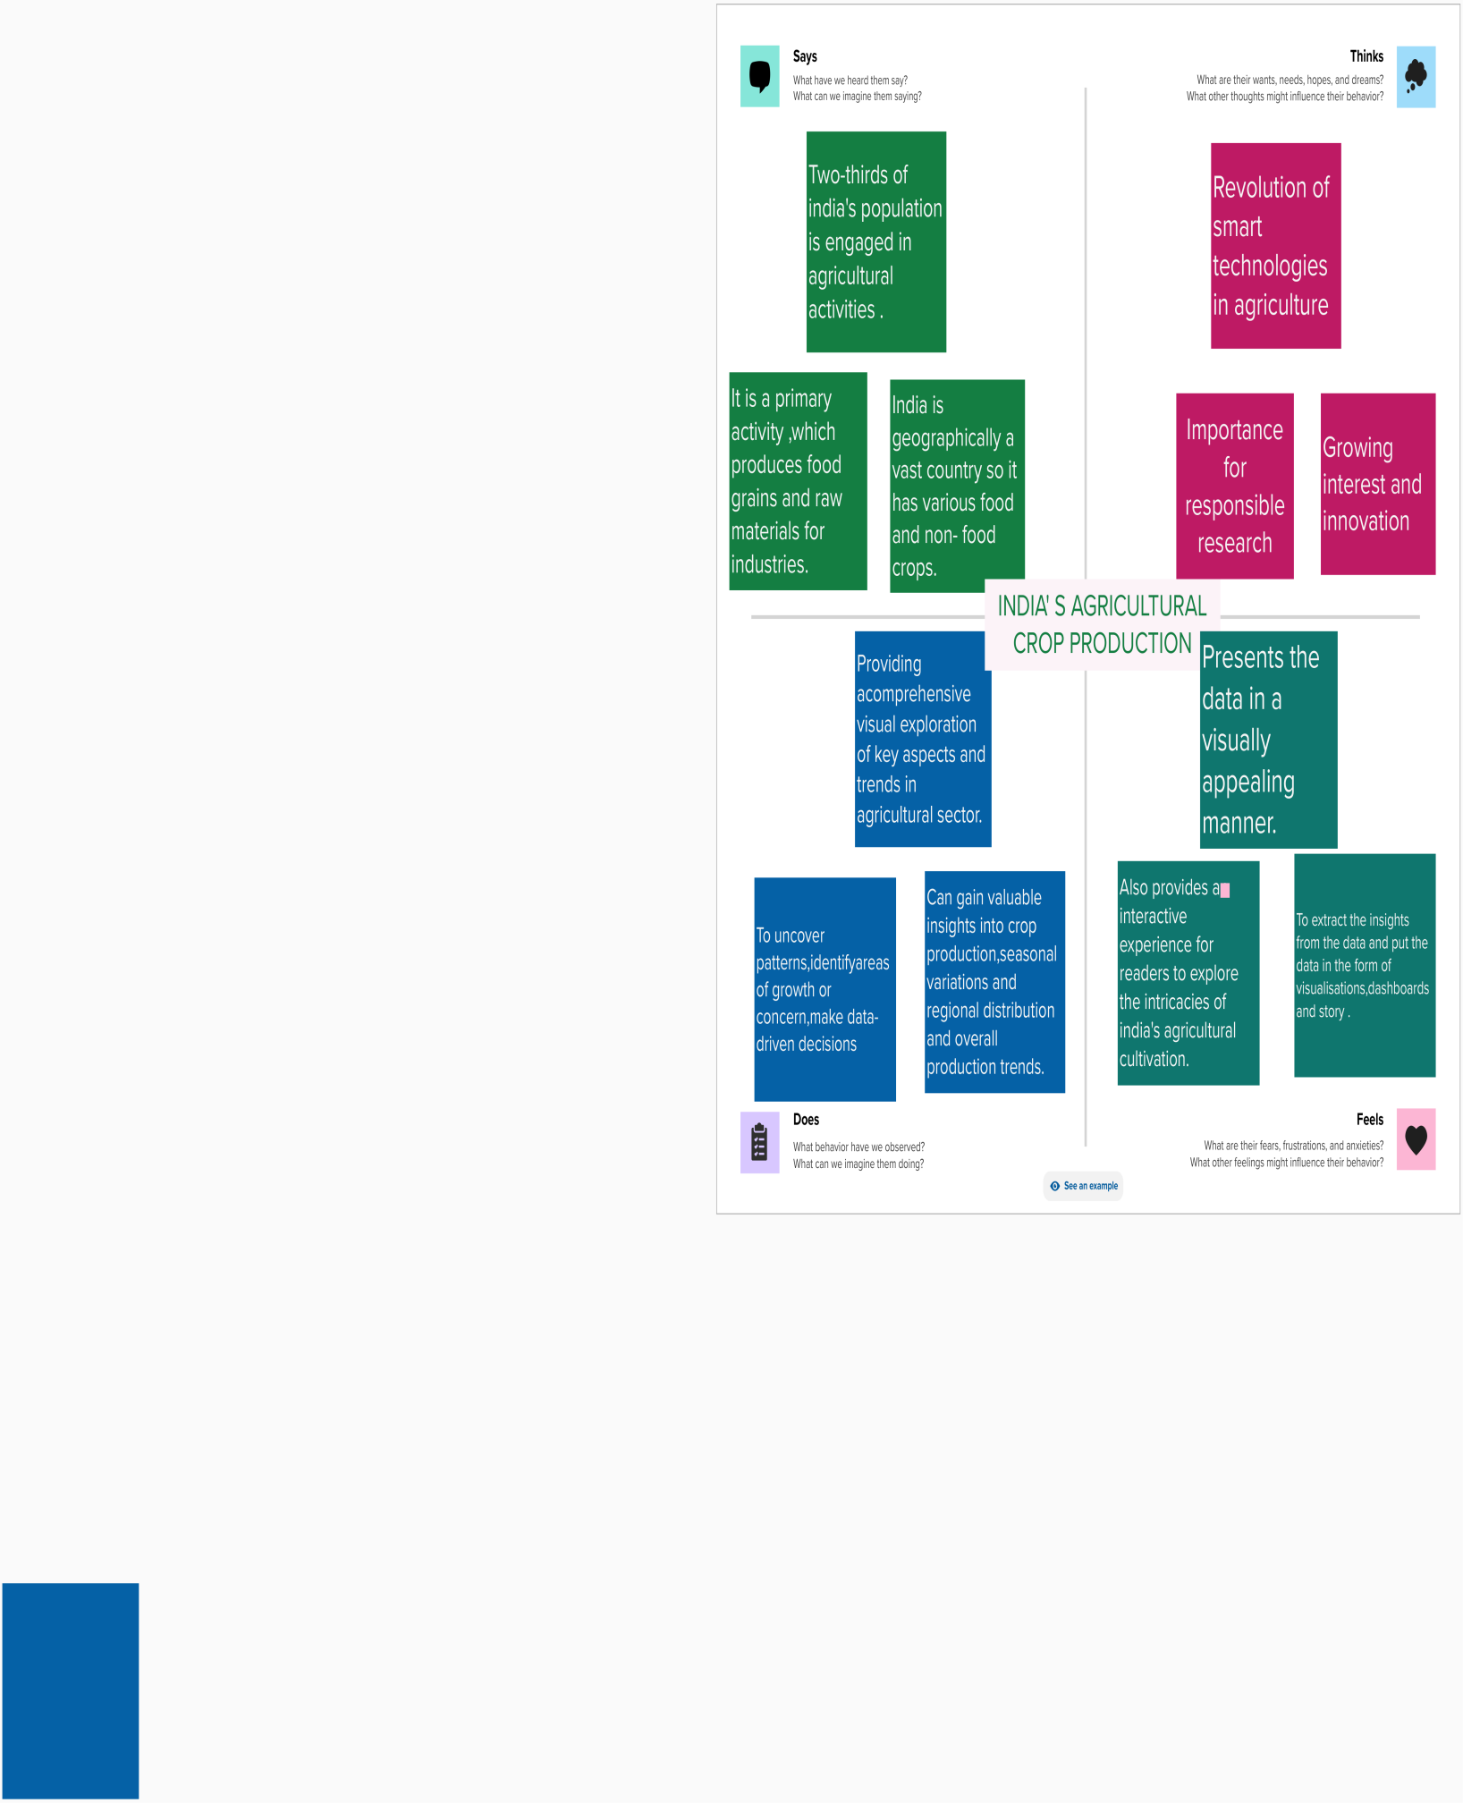

**2.2 IDEATION AND BRAINSTORMING MAP**

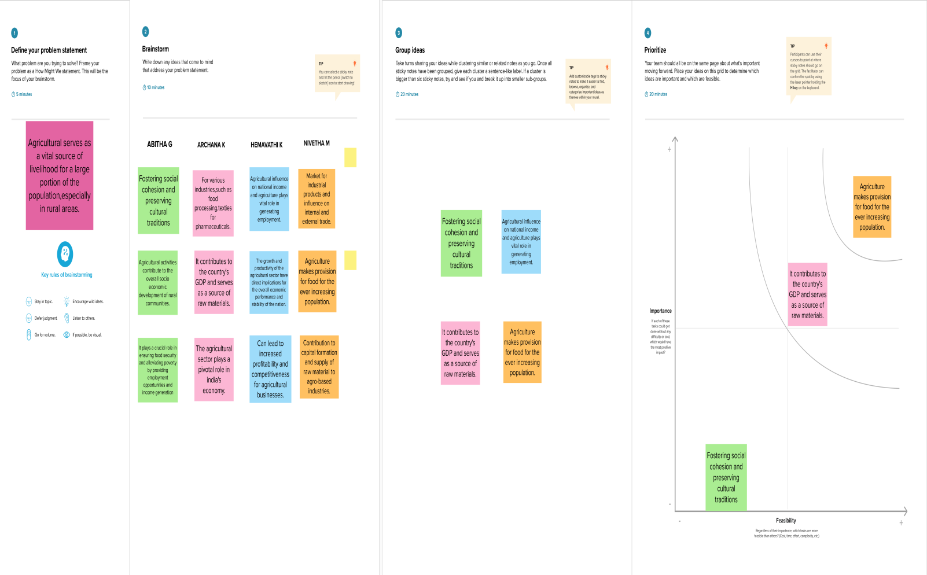

**3. RESULT**

**3.1 DASHBOARD**

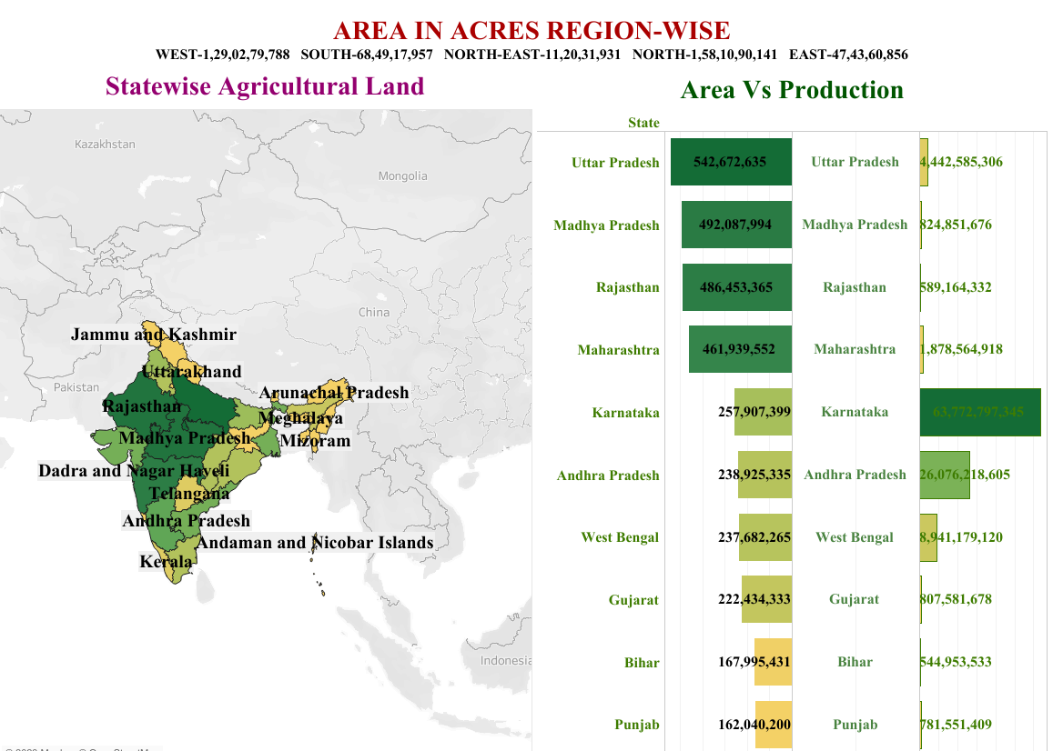

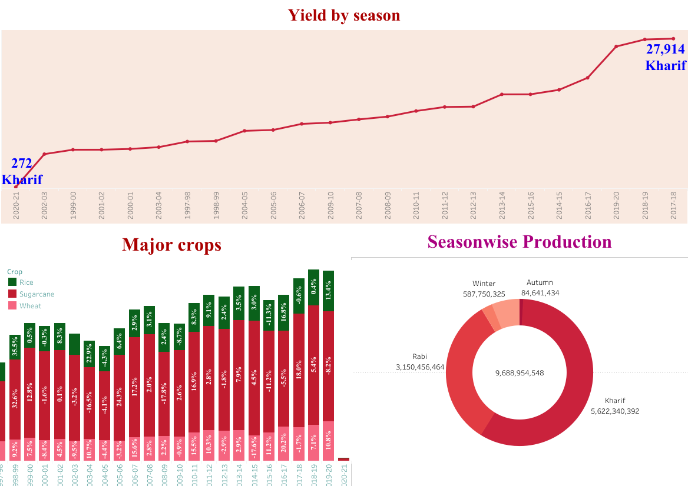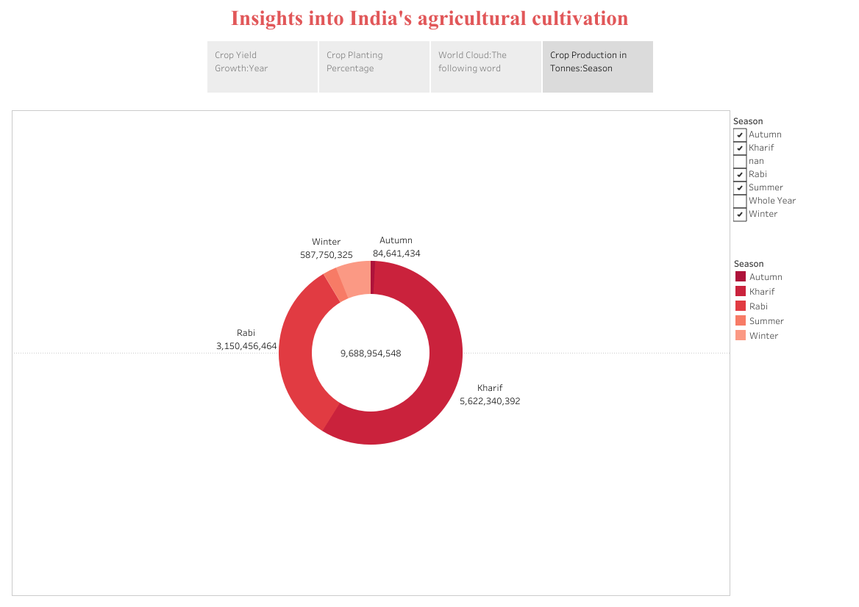

**3.2 STORY**

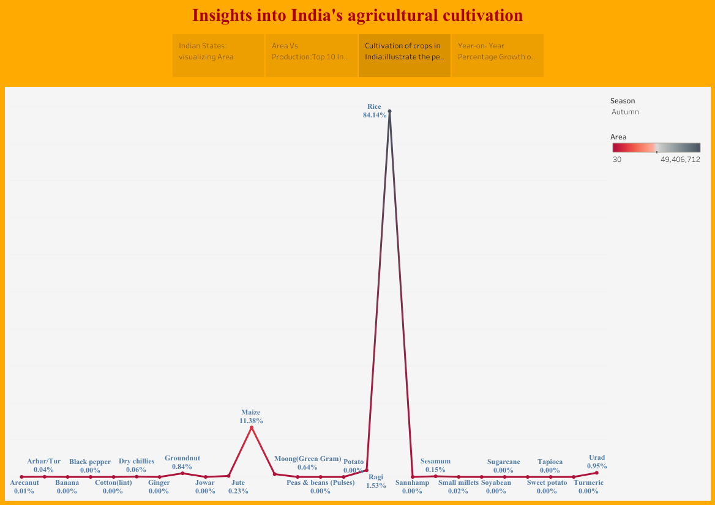

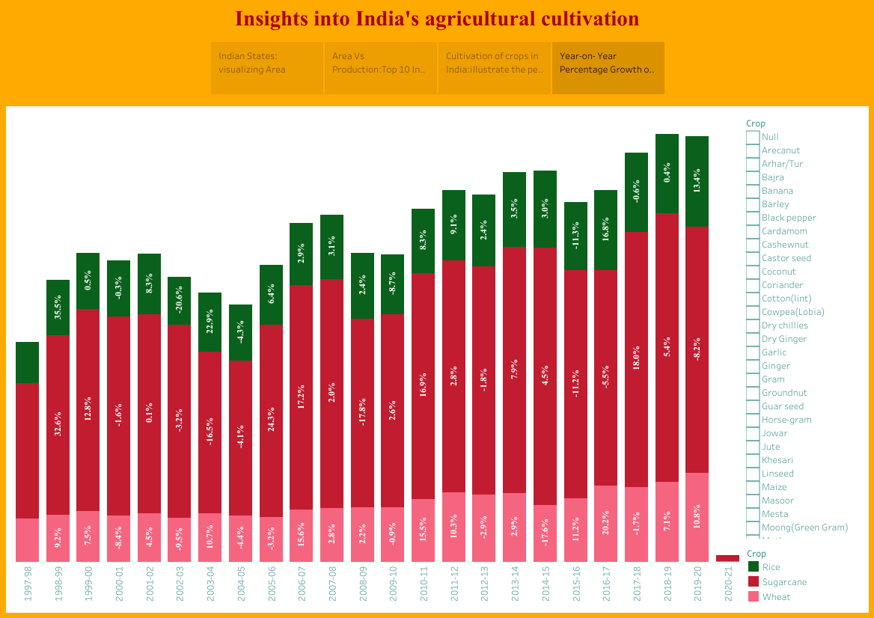

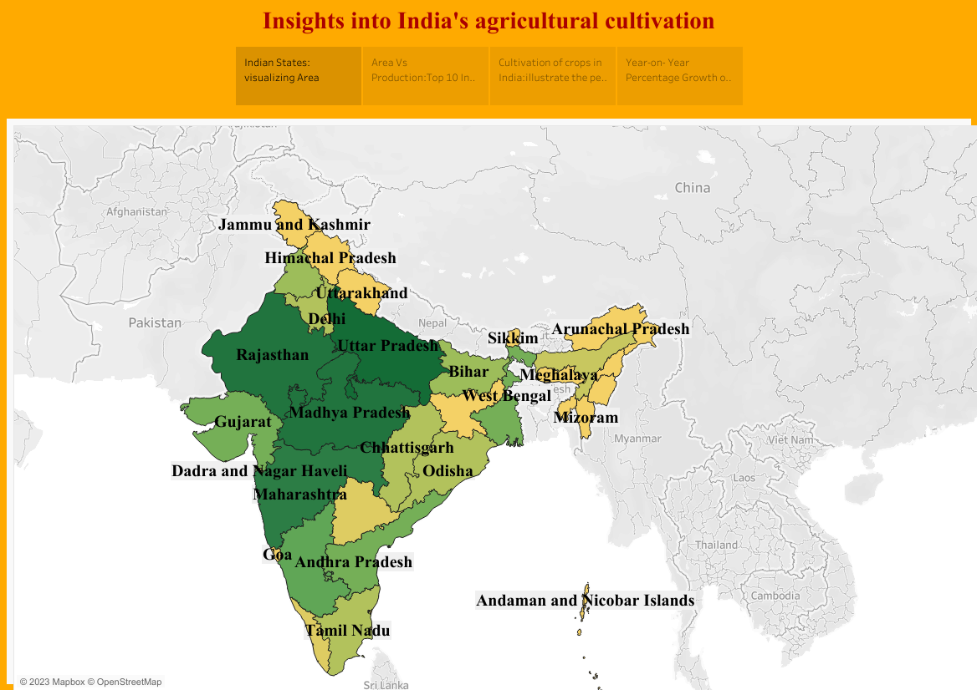

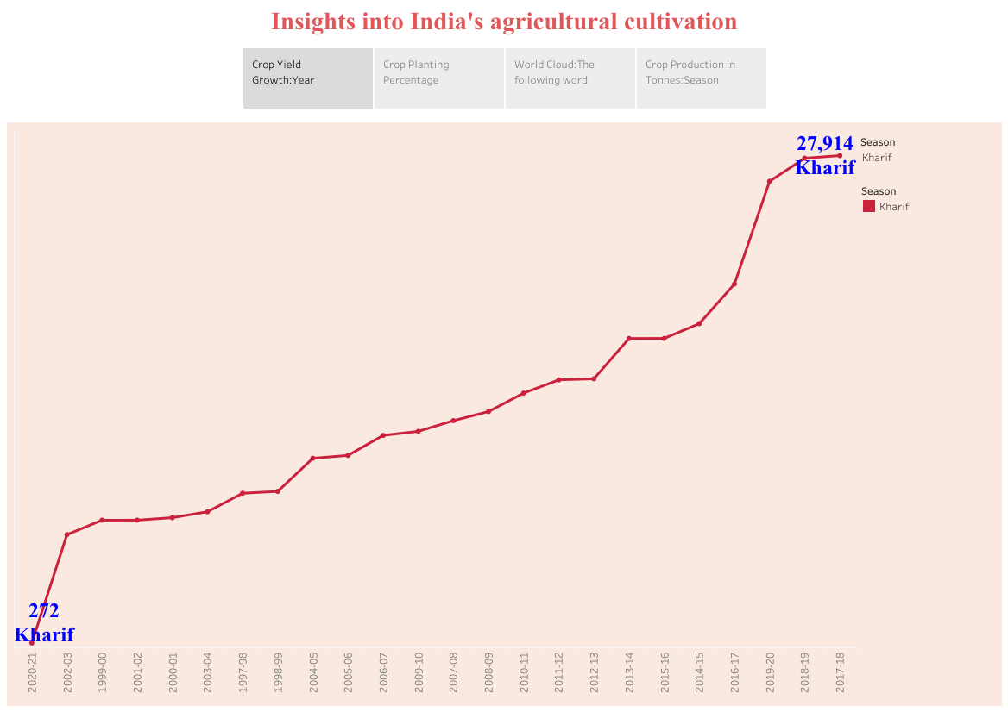

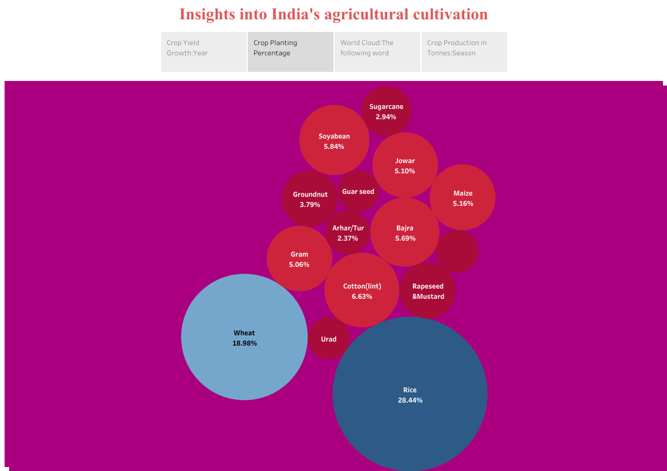

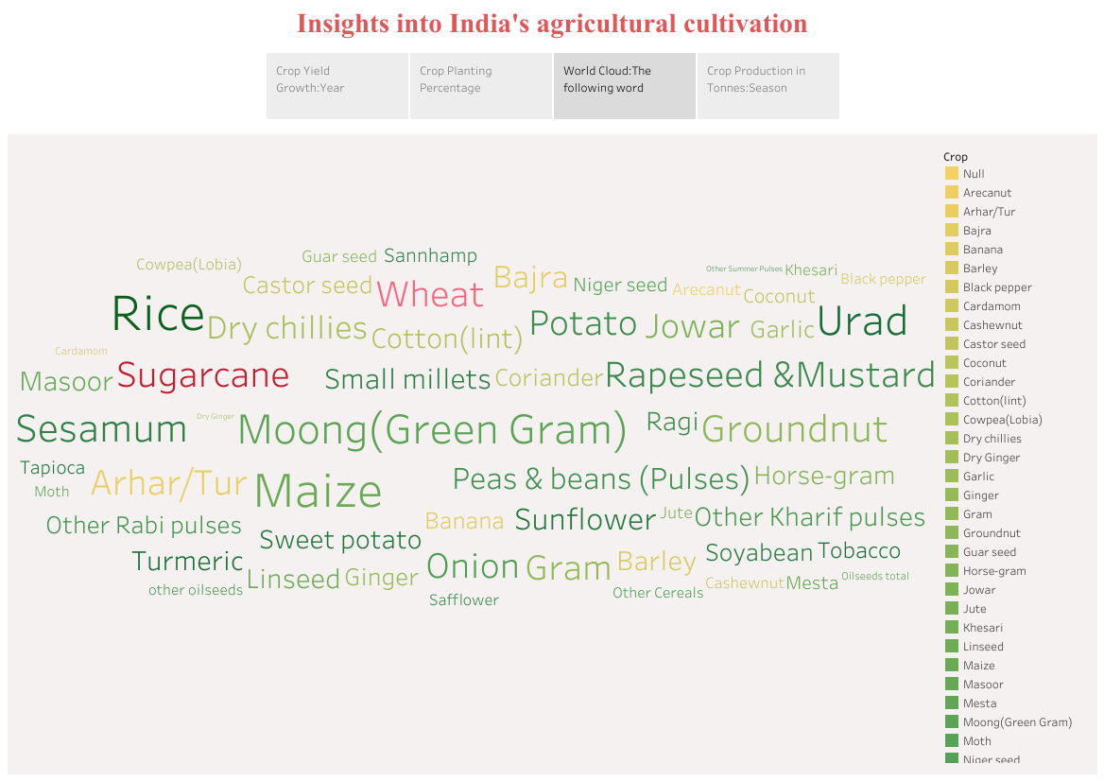



**4. ADVANTAGES AND DISADVANTAGES**

**4.1 ADVANTAGES**

* Organic farming usually goes down in a natural environment.Unnessary enclosures are not used for the crops or plants .
* An open and natural area for growing the crops would give them wild and instinctive growing nature.
* Unlike other forms of farming ,organic farming does not involve any artificial sources like chemicals to drive away pests or to speed up the process of farming.
* These chemicals are often used in commercial and industrial farming methods .
* Unlike any other procedure, organic farming has a very strict supervision schedule.
* The reason for this extreme regulation is because of the importance to keep the label organic.
* Today, almost the entire sector of industrial farming consists of chemicals that rain the environment.
* When you have something like organic farming to replace it, a huge benefit is received.
* Since non-organic farming produces results that are way too suspicious when eaten it is obvious that it isn’t good for health.
* Since the fruits and vegetables grown organically are given longer time to flourish, they automatically are way better in terms of nutrition and taste.

**4.2 DISADVANTAGES**

* One of the major problems of organic farming methods is that sometimes it can get a bit costly .The people to not be able afford it.
* In a country like india where most of its livelihood are farmers,organic farming bring a huge problem.How ever,organic farming in tamilnadu have had some success stories.
* Organic farming is a sector that requires a lot of patience.This is because pests and other obstacles must be tackled manually.
* Organic farming has to be executed well which needs a lot of time and not to forget weed-prevention.
* It is almost obvious that due to the extreme care taken to go along with organic farming,the results would be kept at a high price.
* So,we can say that organic items are expensive and not every consumer is willing to pay the price for it.
* The seeds of genetical modified organism plants once planted,create genetical modified organism crops.
* This makes it very difficult to tell from the organic and genetical modified organism crops.This has a huge problem in organic farming sector.
* In organic farming,one is not able to do it by oneself,a lot of labour would be hired which increases the payment that those labours deserve.
* So, people are starting to prefer organic farming and performing such practises-like mushroom cultivation, aloe vera farming, sugarcane cultivation ,etc..

**5. APPLICATIONS**

* Spraying weedicides on the weeds.
* Manually plucking the weeds by hands .
* Removing weeds by trowel and harrow.
* Ploughing the field to remove the weeds even before sowing the seeds.
* The process of separating the grains from their chaffs or pods is threshing.
* After threshing,we must separate the grains from the chaffs .Winnowing is the process of separating the grains.
* Cultivated grains must be stored safely to avoid product loss.
* Chances of grain loss are much higher during this time than before cultivation.
* Common pests and rodents and some environmental conditions like humidity and temperature are the responsible factors for the loss.
* According to modern agricultural technologies,there are various tools for managing weeds,insects,and diseases.

**6. CONCLUSION**

On overall view, India has always been benifited by AGRICULTURE. Though the future of india is industrialiation, the contribution of agriculture would always prove to be vital for making india a powerful and stable economy in the future. The agricultural sector is playing a very important role in the country like india and the prosperity of the Indian economy still largely depends on agricultural sector. Agricultural development is the basic pre-condition of sectoral diversification and development of the economy.

**7. FUTURE SCOPE:**

* There will be more of vertical and urban farming and there will also be efforts in long term to find new areas for production like barren deserts and sea water .
* “By 2050,there will be gene-edited crops ,and it will trigger a much wider variety of crops being grown”.
* In by 2030 needs a hectare of land to feed five persons against two at present.
* Projects that demand for food,agriculture and fisheries products will continue to grow over the next decade.
* There is a bright future in agriculture field.